INTELLIGENT PUBLIC TRANSPORT
CROWDING & ROUTE PREDICTION
Solution Architecture Document
Internal Smart India Hackathon (SIH) Reference Architecture

Architecture objective: predict how crowded and delayed public-transport options will be before the passenger reaches them, then recommend the best route or departure time while simultaneously giving operators a city-level demand and congestion view.

Document Item | Value
Problem statement | Intelligent Public Transport Crowding & Route Prediction
Primary users | Passengers, transit control-room operators, planners
Reference demo geography | Delhi bus network (adaptable to any GTFS-based system)
Architecture style | Event-driven, spatiotemporal data platform + ML inference + multi-objective routing
Prototype profile | Single-node/container deployment with real GTFS/live vehicle data and pluggable occupancy feed
Production profile | Horizontally scalable services with streaming ingestion, model serving, observability and resilient storage
Document date | 27 August 2026

This document is intentionally more detailed than a hackathon submission. It is designed to serve as the technical source of truth for system design, implementation planning, judging Q&A, demo preparation and later production hardening.

Contents
- 1. Executive summary
- 2. Problem definition and scope
- 3. Stakeholders and use cases
- 4. Requirements
- 5. Architecture principles and key decisions
- 6. Data architecture and real-data strategy
- 7. End-to-end logical architecture
- 8. Component design
- 9. Machine-learning architecture
- 10. Routing and recommendation engine
- 11. Storage and data model
- 12. API and event contracts
- 13. Runtime flows and sequence behavior
- 14. Deployment architecture
- 15. Security, privacy and governance
- 16. Reliability, scalability and observability
- 17. MLOps and model lifecycle
- 18. Testing and validation strategy
- 19. SIH demo architecture and script
- 20. Implementation roadmap
- 21. KPIs and acceptance criteria
- 22. Risks and mitigations
- 23. Future extensions
- 24. Technology stack
- 25. References
- Appendix A. Example payloads
- Appendix B. Judge-facing technical answers

1. Executive summary
The proposed system is a predictive public-transport intelligence platform. It does not merely show the current location of a bus or the current crowd level. It forecasts future crowding, arrival delay and journey reliability for each feasible itinerary, then ranks the alternatives according to the passenger’s preference: fastest, least crowded, most reliable or balanced.
The core differentiator is the prediction-to-decision loop. Live vehicle movement and occupancy signals are combined with static transit topology, historical passenger flow, headway behavior, weather, events and time-of-day patterns. The ML layer predicts occupancy and ETA distributions at future stops. A transit routing engine produces candidate journeys, and a multi-objective ranker scores them using those forecasts. When new vehicle or crowd events materially change the prediction, the system can re-score the active journey and recommend a different route or departure time.
The same intelligence is exposed to a transport-authority dashboard. Instead of only reacting to existing overcrowding, operators receive predicted hotspots, route-level demand buildup, delay clusters and suggested capacity interventions such as short-turning, adding a bus, adjusting headway or shifting reserve vehicles.
The architecture keeps “ground truth”, “derived”, and “simulated” data explicitly tagged. Synthetic occupancy may be used for a controlled SIH demo, but the production interfaces are designed for real APC, AFC/e-ticketing, crowdsourcing or operator-supplied occupancy feeds without changing downstream services.

1.1 Core outcomes
- Predict vehicle/route occupancy 5, 10, 15 and 30 minutes ahead and/or at the passenger’s boarding stop.
- Predict ETA, segment travel time, delay probability and confidence intervals.
- Generate feasible public-transport itineraries and rank them using predicted rather than only current conditions.
- Recommend alternative departure times when waiting produces a materially better crowd/reliability outcome.
- Continuously adapt the recommendation when new real-time data arrives.
- Give operators a network-level view of predicted crowding, delay and service instability.
- Create an auditable historical dataset from live feeds for future model improvement.

1.2 What the user sees
Option | Travel time | Predicted crowd at boarding | Delay risk | Result
Bus 14 | 34 min | 91% / very crowded | High | Avoid
Bus 22 | 39 min | 42% / seats likely | Low | Recommended
Bus 31 | 31 min | 72% / standing possible | Medium | Fastest

The recommended option is not hard-coded. It is the result of a generalized cost function that uses predicted journey time, waiting, transfers, walking, crowd discomfort, delay uncertainty and the user’s selected preference profile.

2. Problem definition and scope

2.1 Problem statement
Public-transport users normally make route decisions with incomplete information. A route planner may know the scheduled trip, current vehicle location or estimated arrival time, but the user often does not know whether the arriving vehicle will be overcrowded, whether crowding will worsen before their stop, or whether a slightly later departure would produce a substantially better journey. Operators face the inverse problem: crowding and delay signals become obvious only after the service is already degraded.
The proposed platform treats public transport as a spatiotemporal prediction problem. It estimates the future state of the network and turns that state into passenger and operator decisions.

2.2 In scope
- GTFS schedule ingestion and transit-network graph construction.
- GTFS-Realtime/AVL vehicle-position ingestion and map matching.
- Occupancy ingestion from automatic passenger counters (APC), automatic fare collection (AFC), crowdsourcing, operator feeds or a simulator.
- Historical data collection and feature engineering.
- Crowding, passenger-flow, ETA and delay forecasting.
- Multi-modal candidate journey generation (bus/metro/walk where data is available).
- Multi-objective route and departure-time recommendation.
- Passenger-facing map, route comparison and live journey updates.
- Authority dashboard for predicted hotspots and fleet-action recommendations.
- Observability, model monitoring, data-quality controls and auditability.

2.3 Explicitly out of scope for the first release
- Autonomous control of transit vehicles or signals.
- Guaranteeing seat availability; predictions are probabilistic.
- Replacing the transport operator’s dispatch system. The platform provides recommendations and integration APIs.
- Continuous storage of identifiable passenger movement. The design minimizes personal location retention.
- Fare payment, ticket issuance or financial settlement, although AFC data may be consumed as an aggregate input.
- Computer-vision surveillance of passengers as a mandatory dependency.

2.4 Reference geography
The reference prototype uses Delhi because the Delhi Open Transit Data portal publishes bus GTFS static data and offers an authorized real-time VehiclePositions feed. The architecture itself is location-agnostic: any city exposing GTFS/GTFS-Realtime or equivalent operator feeds can be integrated through adapters. [R1–R3]

3. Stakeholders and use cases
Stakeholder | Primary goals | Key system capabilities
Passenger | Reach destination with preferred trade-off between time, comfort and reliability | Route search, crowd forecast, ETA, departure recommendation, live reroute, alerts
Transit control room | Detect future overload and delay before service collapses | Hotspot map, route forecast, fleet-state view, intervention suggestions
Planning/analytics team | Understand recurring demand patterns | Historical dashboards, route/stop heatmaps, model exports, KPI trends
Data/ML team | Maintain predictive quality | Feature pipelines, model registry, drift/error monitoring, retraining
System administrator | Operate safely and reliably | RBAC, data-source health, audit logs, configuration, rate limits
Transport authority/API partner | Integrate operational systems | Data contracts, API keys, APC/AFC/AVL adapters, governance controls

3.1 Passenger use cases
- Plan a journey from origin to destination and compare alternatives by predicted crowding and delay.
- Choose Fastest, Least Crowded, Most Reliable or Balanced preference.
- See forecast occupancy at the exact future boarding stop rather than only current vehicle occupancy.
- Receive “leave 15 minutes later” advice when future crowding materially improves.
- Receive a live notification if the selected trip becomes significantly more crowded or delayed.
- Report observed crowd status using simple ordinal categories when operator occupancy is unavailable.
- View accessible alternatives subject to mobility constraints.

3.2 Operator use cases
- View predicted crowding by route, trip, vehicle, stop and time horizon.
- Identify where passenger accumulation is likely to exceed capacity.
- Identify bunching, headway instability and recurrent delay segments.
- Compare “do nothing” with capacity actions such as adding a vehicle or changing headway.
- Review forecast confidence so human operators can distinguish strong signals from uncertain ones.
- Export route-level operational summaries for planning.

4. Requirements

4.1 Functional requirements
ID | Requirement
FR-01 | Import GTFS schedule data and construct stop/route/trip relationships.
FR-02 | Consume vehicle positions at a configurable polling/streaming interval and retain raw observations.
FR-03 | Map-match each vehicle to a trip/route/segment and detect stale or impossible positions.
FR-04 | Ingest occupancy observations with source, timestamp, capacity and confidence metadata.
FR-05 | Join weather/event/context data by location and time.
FR-06 | Compute current service state: location, speed, headway, schedule deviation, next stop and occupancy state.
FR-07 | Forecast crowding/occupancy at future stops and time horizons.
FR-08 | Forecast segment travel time, ETA, delay and uncertainty.
FR-09 | Generate candidate itineraries satisfying service schedules and transfer rules.
FR-10 | Rank itineraries under selectable user preferences.
FR-11 | Recommend alternative departure windows when beneficial.
FR-12 | Re-score active recommendations when material new data arrives.
FR-13 | Expose passenger and operator APIs plus real-time update channel.
FR-14 | Show route/vehicle/hotspot maps and forecast explanations.
FR-15 | Store feedback/outcome data for model evaluation and retraining.
FR-16 | Record whether every data point is real, inferred, crowdsourced or simulated.

4.2 Non-functional requirements
Attribute | Target / design intent
Latency | Journey recommendation p95 < 2.5 s for normal city searches; live re-score < 1.5 s once updated features are available.
Freshness | Vehicle state target < 15–30 s old where the upstream feed supports it; stale data must be visibly flagged.
Availability | Production target 99.9% for passenger read APIs; graceful degradation when an external feed fails.
Scale | Partition by city/agency/route and horizontally scale ingestion and inference independently.
Security | TLS, scoped credentials, RBAC for operator functions, encryption at rest, secrets manager.
Privacy | Minimize storage of personal location; separate analytics identifiers from account identity; configurable retention.
Explainability | Every recommendation should expose the dominant reasons: time, crowd, delay risk, transfer count, uncertainty.
Auditability | Model version, feature timestamp and source provenance must be logged with high-impact recommendations.
Portability | Adapters isolate city-specific APIs from the canonical transit and occupancy models.
Resilience | Fallback to historical estimates when live positions, occupancy or weather become unavailable.

5. Architecture principles and key decisions

AP-01: Predict the future state, not merely display current state
The product value comes from forecasting occupancy and delay at the time/place relevant to a future boarding decision.

AP-02: GTFS as the canonical transit topology
Routes, trips, stops and stop-times are normalized into a canonical model so city integrations do not leak into business logic.

AP-03: Event-driven live state
Vehicle positions, occupancy updates, traffic/context changes and feedback are immutable timestamped events. Derived current state is materialized separately.

AP-04: Separate raw, derived and simulated data
Every observation carries provenance and quality metadata. Simulated data can exercise the pipeline without being mistaken for operational truth.

AP-05: Prediction uncertainty is first-class
The API returns ranges/quantiles and confidence, not only a single point estimate. Route ranking can penalize uncertainty for reliability-sensitive users.

AP-06: Candidate generation and ranking are separate
A deterministic transit planner generates feasible journeys; ML forecasts enrich them; a preference-aware ranker selects among them.

AP-07: Graceful degradation
If live occupancy is missing, use historical passenger-flow forecasts. If live GPS is missing, fall back to schedule/headway estimates. The app indicates degraded confidence.

AP-08: Prototype and production share contracts
Hackathon deployment may collapse logical services into fewer processes, but data schemas and APIs remain production-shaped.

5.1 Major architecture decisions (ADRs)
ADR | Decision | Reason
ADR-01 | Event stream for live observations | Decouples ingestion rate from model/ranking workloads and preserves replayability.
ADR-02 | PostgreSQL + PostGIS as canonical operational store | Strong relational model plus spatial queries for stops, routes and geofences.
ADR-03 | Time-series optimized storage for dense telemetry | Efficient vehicle-position and forecast-history queries; can use TimescaleDB extension or dedicated time-series store.
ADR-04 | Object storage + Parquet for training history | Low-cost immutable history and efficient batch ML scans.
ADR-05 | GBDT production baseline before deep sequence models | Strong tabular/time-feature performance, fast inference and easier explanation; advanced models can be introduced only if they beat baselines.
ADR-06 | RAPTOR/CSA-style transit planner | Transit-specific routing handles timetables and transfers better than generic road-only shortest path.
ADR-07 | Quantile forecasts | p10/p50/p90 enable reliability-aware decisions and honest uncertainty display.

6. Data architecture and real-data strategy
The system requires several data domains. No single public dataset is expected to contain all of them. The architecture intentionally joins independent feeds into a time-aligned canonical model.

6.1 Data-source matrix
Domain | Preferred source | Canonical fields | Update pattern | Fallback
Transit topology | GTFS Schedule | agency, route, trip, stop, stop sequence, calendar, shape | Daily/when publisher updates | Last known valid feed
Vehicle movement | GTFS-Realtime VehiclePositions / AVL | vehicle_id, trip_id, lat, lon, timestamp, stop sequence | 5–30 s typical | Schedule + historical segment times
Occupancy | APC / AFC / operator load feed | vehicle/trip, board, alight, onboard, capacity, confidence | Per stop / seconds-minutes | Historical prediction or simulator
Crowdsourcing | Passenger reports | vehicle/trip, ordinal crowd class, timestamp, reporter confidence | Event-driven | Ignore if insufficient consensus
Weather | Forecast + historical weather API | rain, precipitation probability, temperature, humidity, weather code | Hourly or forecast refresh | Recent value / climatology
Events | Authority/event calendar | location, start/end, expected attendance, event class | Daily/event-driven | No-event assumption
Traffic/context | Road speed or inferred bus segment speed | segment speed, congestion index | Minutes | Historical segment profile
Capacity | Fleet master data | vehicle_type, seated/total capacity | Rare changes | Route-level default

6.2 Delhi reference integration
The Delhi Open Transit Data portal publishes static bus data in GTFS format and exposes an authorized real-time VehiclePositions endpoint. Its documentation states that the static timetable files include agency.txt, calendar.txt, stops.txt, routes.txt, trips.txt and stop_times.txt. The portal also warns that arrival/departure times in stop_times.txt are rough estimates generated using an assumed constant speed; therefore the architecture uses them primarily for topology/service definition and learns operational travel times from live observations. [R1–R3]
The current static-data page lists 3,464 active stops/terminals, 543 routes, 16,562 trips and 378,324 stop-time records, with the page indicating a June 20, 2024 update date. This is sufficient for a realistic city-scale prototype even though the feed itself should be revalidated before production. [R1]
The real-time access form explicitly includes “Student Projects” as a purpose, making it suitable for an SIH prototype subject to the portal’s terms and authorization. [R2]

6.3 GTFS normalization
GTFS Schedule defines a common structure for public-transport data. Required/core files such as routes.txt, trips.txt and stop_times.txt establish route identity, trip sequences and stop arrival/departure structure. The importer validates referential integrity, service dates, coordinates and stop sequences before publishing a new feed version. [R4]
GTFS ZIP -> schema validator -> staging tables -> canonical IDs -> geometry build -> service calendar expansion -> publish feed_version

6.4 Real-time vehicle state
GTFS-Realtime VehiclePositions supports vehicle location, trip linkage, timestamps, current passage and optional occupancy status. Even if a local operator does not publish occupancy, the vehicle-position feed still provides the backbone for ETA and delay estimation. [R5]
- Reject positions outside geographic bounds or with impossible speed jumps.
- Map-match each point to the expected route shape or stop-to-stop segment.
- Mark feed entries stale when age exceeds a configurable threshold.
- Deduplicate repeated timestamps and retain raw upstream payload hashes for audit.
- Infer segment travel time from successive positions and stop-passage events.
- Materialize “latest vehicle state” in Redis while retaining historical events in the time-series store/object storage.

6.5 Occupancy strategy
Occupancy is the most operator-specific data source. The platform supports a hierarchy of sources, each mapped into the same observation contract:
- APC: door sensors/camera counters provide boardings, alightings and onboard count; usually the strongest operational ground truth.
- AFC/e-ticketing: taps or tickets provide boarding demand; alighting may require tap-out data or inference.
- Operator load feed: direct vehicle load/occupancy category if already available.
- Crowdsourcing: user reports such as seats available / few seats / standing / very crowded; combine multiple reports using recency and reputation/confidence.
- Simulation: synthetic board/alight events generated from realistic route, stop and time-of-day patterns. Always marked source_type=SIMULATED.
For the SIH demo, synthetic occupancy is acceptable as an instrumentation substitute, but model metrics on synthetic labels must be presented as simulator performance—not real-world accuracy.

6.6 External real passenger-flow data for model experimentation
Transport for London publishes BUSTO, an annual CSV dataset estimating bus boardings, alightings and loadings for typical weekdays, Saturdays and Sundays. It can be used to validate feature pipelines or pretrain/benchmark passenger-flow methods, while the Delhi demo retains Delhi-specific topology and live vehicle movement. [R6]

6.7 Weather and context
Open-Meteo provides hourly historical weather variables such as temperature, humidity, precipitation and weather codes, with historical APIs backed by reanalysis/model data. These variables are joined to the transport timeline by location and timestamp. [R7]

6.8 Data provenance contract
observation_id | city_id | agency_id | entity_id
source_type = REAL_OPERATOR | PUBLIC_FEED | CROWDSOURCED | DERIVED | SIMULATED
source_name | source_timestamp | ingest_timestamp
quality_score [0..1] | raw_payload_ref | schema_version
This contract prevents synthetic or inferred values from contaminating “real-data” evaluations and allows models to learn source-specific reliability.

7. End-to-end logical architecture
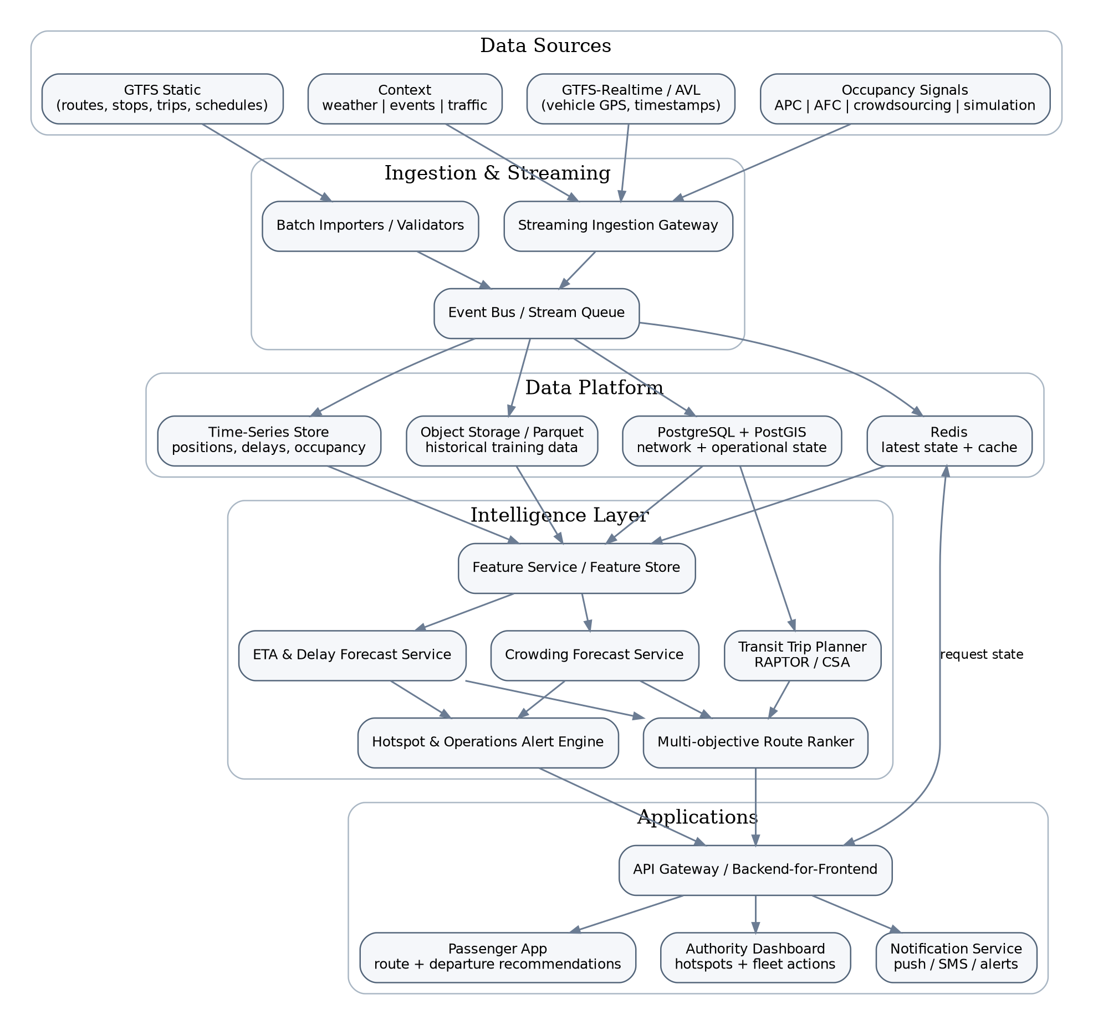
Figure 1. End-to-end logical architecture
The architecture is divided into five planes: source adapters, ingestion/streaming, data platform, intelligence layer and applications. Services communicate through stable schemas rather than city-specific payloads.

7.1 Request path
1. Passenger submits origin, destination, departure/arrival time and preference profile.
2. Trip Planner generates feasible itineraries using the current GTFS service graph.
3. Feature Service snapshots the latest relevant vehicle, headway, occupancy, weather and historical features for each candidate.
4. Crowding and Delay services produce forecasts for the candidate segments/trips, including uncertainty.
5. Route Ranker computes generalized cost and returns several labeled alternatives, not just one opaque recommendation.
6. Backend streams material changes during the journey using WebSocket/SSE/push notifications.

7.2 Streaming path
1. Source adapters fetch/receive GPS, occupancy and context events.
2. Schema validation, deduplication, timestamp normalization and source-quality tagging occur at ingress.
3. Events are published to the stream bus and persisted to raw history.
4. Stream processors update latest vehicle/route state, headway, stop passage and derived segment travel times.
5. Affected features and forecasts are recomputed selectively rather than re-predicting the whole city.
6. Active user itineraries and operator hotspots subscribed to those entities are re-scored.

8. Component design
Component | Responsibility | Important behavior
GTFS Importer | Validates ZIP feed, versions source, normalizes agency/route/trip/stop/calendar/shape tables, builds spatial indexes and trip-stop graph. | Scheduled batch; idempotent by feed hash.
Realtime Adapter | Fetches or subscribes to VehiclePositions/AVL. Converts Protocol Buffers/vendor JSON into canonical vehicle_position events. | Stateless; horizontally scalable by agency/feed.
Occupancy Adapter | Accepts APC/AFC/operator/crowd/simulator inputs and standardizes onboard count or ordinal occupancy. | Adds capacity and confidence; resolves vehicle/trip association.
Stream Processor | Deduplicates, map-matches, detects stop passage, computes speed/headway/schedule deviation and updates current state. | Partitions by city/route/vehicle.
Feature Service | Builds low-latency feature vectors using historical aggregates plus latest live state. | Online/offline feature parity required.
Crowd Forecast Service | Predicts boardings, alightings or occupancy ratio/bucket for future stops/horizons. | Returns quantiles and source/model metadata.
Delay Forecast Service | Predicts segment travel time, stop ETA, end-to-end journey time and delay risk. | Uses live speed/headway and historical segment patterns.
Transit Trip Planner | Generates schedule-feasible candidate journeys and transfers. | RAPTOR/CSA; optional walking links from spatial network.
Route Ranker | Scores candidates according to preference profile, hard constraints and prediction uncertainty. | Deterministic formula over predicted features; explainable.
Recommendation Orchestrator | Coordinates planner, forecasts, ranker and active-trip subscriptions. | Main passenger request service.
Operations Alert Engine | Aggregates future capacity/delay risk into hotspot windows and suggested interventions. | Threshold + model-based rules.
Passenger BFF/API | Authentication, geocoding integration, trip endpoints, WebSocket/SSE updates. | Caches popular OD/time queries.
Admin BFF/API | Role-controlled route/vehicle/hotspot queries and operational actions. | No passenger PII required for core dashboard.
Notification Service | Push/SMS/email integration for trip disruption or operator alerts. | Deduplicates noisy alerts and enforces cooldown.
Model Registry/MLOps | Version models, metrics, feature schema, promotion status and rollback. | Every prediction records model_version.

8.1 Map matching and stop passage detection
Raw GPS points must be converted into transit semantics. The processor identifies the most likely route segment based on trip assignment, route shape, bearing, distance and sequence constraints. A stop passage event is emitted when the vehicle enters/leaves a stop geofence or when position interpolation crosses the stop sequence. Stop passage events are critical because they provide stable labels for segment travel-time learning.
vehicle_position -> candidate route segments -> score(distance, heading, expected_sequence) -> matched_segment -> stop_passage/segment_travel_time

8.2 Headway and bunching service state
For high-frequency bus networks, schedule deviation alone can be misleading. The platform therefore tracks headway: time gap between consecutive vehicles on the same route/direction. Features include current headway, planned headway, headway ratio, previous-bus gap and following-bus gap. Persistent low headway between two vehicles indicates bunching and is a strong delay/crowding signal.

8.3 Crowd report fusion
Crowdsourced occupancy is treated as noisy evidence, not ground truth. Reports are weighted by recency, agreement with other users, reporter reliability (if available without intrusive identity tracking) and compatibility with vehicle capacity. The result is a posterior crowd-state estimate with a confidence score. Operator APC data overrides crowd reports when fresh and trusted.

9. Machine-learning architecture
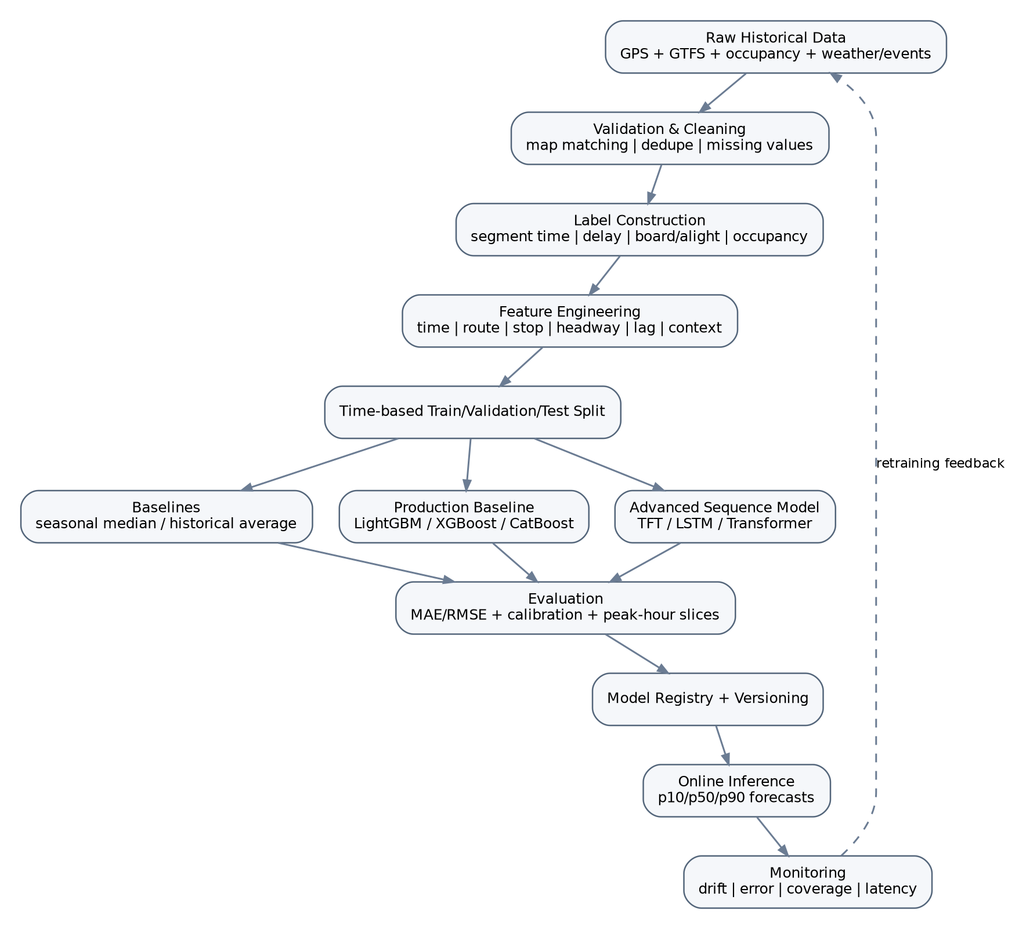
Figure 2. Training, evaluation and online inference lifecycle

9.1 Prediction tasks
Task | Target | Example output | Primary use
Crowd regression | Occupancy ratio 0–1 at future stop/horizon | 0.84 (p10=.72, p90=.94) | Route ranking, capacity alert
Crowd classification | Ordinal class | Standing room only | Passenger UI when counts are unavailable
Passenger-flow forecast | Boardings and alightings per stop | +18 board, -6 alight | Propagate occupancy downstream
Segment travel time | Seconds for next road/transit segment | 310 s | ETA construction
Stop ETA | Arrival timestamp distribution | 17:42 p50; 17:39–17:48 interval | Passenger display
Delay risk | Probability threshold exceeded | P(delay>10 min)=0.71 | Reliability score
Hotspot forecast | Capacity exceedance window | Route R12, stops S8–S12, 17:20–17:50 | Operator dashboard

9.2 Feature catalog
Feature group | Examples
Identity/topology | route_id, direction, trip_id, stop_id, stop sequence, segment_id, vehicle type/capacity
Time | hour, minute bucket, day of week, weekend, holiday, school/office peak, cyclical sin/cos time features
Live movement | lat/lon, map-matched segment, speed, acceleration, distance to stop, dwell time, current ETA residual
Headway | actual headway, scheduled headway, headway deviation, previous/following vehicle gap, bunching flag
Occupancy state | current onboard, occupancy ratio/class, last trusted observation age, source confidence
Passenger-flow lags | board/alight/occupancy at prior stops; same trip previous stops; same route previous vehicles
Historical aggregates | median/quantiles by route-stop-time-day; rolling 7/28-day patterns; special-day profiles
Weather | rain, precipitation probability, temperature, humidity, weather code
Events | distance to event, event start/end window, expected attendance bucket, event category
Traffic proxy | current segment travel time / historical median, upstream bus speed, road congestion if provided
Data quality | GPS age, occupancy age, missingness flags, source_type, source quality score

9.3 Model progression
Stage | Crowd model | Delay model | Why
Baseline 0 | Route-stop-time seasonal median | Historical segment median | Establish honest lower bound; zero ML complexity.
Baseline 1 | Gradient-boosted trees on engineered lags | Gradient-boosted trees on segment/live features | Strong performance on heterogeneous tabular data; fast and explainable.
Sequence | TFT/LSTM/Transformer over stop sequence and prior trips | Sequence model over segment trajectory | Learns temporal dependencies and long-horizon interactions.
Network-aware | Graph temporal model across nearby routes/stops | Graph/spatial model for congestion propagation | Captures spillover across shared corridors and transfer hubs.
Production ensemble | Weighted/stacked baseline + sequence model | GBDT + sequence quantile ensemble | More robust across data regimes; fallback when advanced features are missing.

9.4 Recommended first production model
Use gradient-boosted decision trees for the initial production model. They handle route/stop categorical encodings, non-linear relationships, missing values and a mixture of live and historical features with low inference latency. Deep sequence or graph models should be promoted only if they show material gains on time-based holdout sets and peak-hour slices.

9.5 Time-based validation
Random train/test splits leak future patterns into the past and should not be used. Split chronologically: train on earlier weeks/months, validate on a later window and test on the most recent untouched window. Additionally evaluate unseen-event days, rainy days, peak periods and routes with sparse observations.

9.6 Metrics
Layer | Metrics
Occupancy regression | MAE, RMSE, weighted MAE near capacity threshold, quantile pinball loss
Occupancy class | Macro F1, weighted F1, ordinal error, confusion around “standing/full” threshold
Board/alight | MAE per stop, cumulative occupancy conservation error
ETA/delay | MAE in minutes, p90 absolute error, on-time-within-5-min rate, calibration
Ranking | Top-1 regret vs observed outcome, route-switch benefit, recommendation acceptance
Operations | Hotspot precision/recall, lead time before capacity exceedance
System | Feature freshness, prediction latency, coverage, fallback rate

9.7 Forecast uncertainty
Crowding and ETA should be returned as distributions or quantiles. Example: occupancy p10=0.62, p50=0.76, p90=0.91. A user selecting “Most Reliable” can prefer a route with a slightly slower median travel time but narrower uncertainty. Operator alerts can require the lower confidence bound to exceed a threshold before escalating.

9.8 Passenger-flow conservation
When models separately predict boardings and alightings, onboard passenger count is propagated using a constrained recurrence:
onboard[s] = clip(onboard[s-1] + boardings[s] - alightings[s], 0, vehicle_capacity)
The system should flag model outputs that imply impossible negative counts or sustained load above physical capacity. Constraint-aware post-processing improves realism and judge confidence.

10. Routing and recommendation engine

10.1 Candidate journey generation
The Trip Planner is deterministic and separate from ML. It uses the transit schedule graph to create feasible journeys between origin and destination, respecting service calendars, stop order, transfer time, maximum transfers and optional walking links. A RAPTOR or Connection Scan Algorithm implementation is appropriate because it is designed for timetable transit routing. For a prototype, an existing GTFS routing library/service may be used behind the same interface.

10.2 Multi-objective generalized cost
score(route) =
wT * normalized_travel_time
+ wW * normalized_wait_time
+ wX * transfer_penalty
+ wC * predicted_crowding_cost
+ wD * delay_risk
+ wU * uncertainty_penalty
+ wP * walking_penalty
Lower score is better. Weights change by preference profile. Hard constraints such as wheelchair accessibility, maximum walking distance or “avoid standing” are applied before ranking.
Preference | Travel | Crowd | Delay risk | Transfers | Interpretation
Fastest | Very high | Low | Medium | Medium | Optimize arrival time while avoiding obviously unstable options.
Least crowded | Medium | Very high | Medium | Medium | Prefer comfort even if travel time rises moderately.
Most reliable | Medium | Medium | Very high + uncertainty | Medium | Prefer narrow ETA distribution and stable headways.
Balanced | High | High | High | Medium | Pareto-style compromise.

10.3 Crowd discomfort function
Crowding should not be treated linearly. Going from 20% to 40% occupancy usually matters less than going from 80% to 100%. Use a piecewise/non-linear penalty that rises sharply near standing/full thresholds. This makes the recommendation align with human experience.
if occ < 0.50: crowd_cost = 0.2 * occ
elif occ < 0.80: crowd_cost = 0.10 + 0.8 * (occ-0.50)
else: crowd_cost = 0.34 + 2.5 * (occ-0.80)

10.4 Departure-time optimization
For a requested departure window, evaluate the best itinerary at several nearby departure times (for example now, +5, +10, +15, +20 minutes). Recommend waiting only when the utility improvement crosses a threshold, avoiding annoying suggestions for trivial gains.
Recommend WAIT if best_score(t + Δ) + waiting_disutility(Δ) < best_score(t) - improvement_threshold

10.5 Live rerouting policy
- Do not reroute on every small forecast fluctuation. Use hysteresis and cooldown.
- Trigger only when expected journey cost worsens beyond a material threshold or a route becomes infeasible.
- Prefer changes before boarding; after boarding, only recommend transfer changes if the benefit is significant.
- Explain the reason: “Bus 14 is now predicted 92% full at your stop; Bus 22 is 44% and 6 minutes slower.”
- Retain the previous recommendation and forecast snapshot for audit and A/B evaluation.

11. Storage and data model

11.1 Storage responsibilities
Store | Data | Access pattern
PostgreSQL + PostGIS | GTFS canonical model, stops, shapes, routes, fleet metadata, users/roles, configuration | Transactional + spatial joins
Time-series store / TimescaleDB | Vehicle positions, stop passages, occupancy observations, feature snapshots, forecast outcomes | Time-window scans, route/vehicle history
Redis | Latest vehicle state, active trip sessions, hot feature values, route-plan cache | Sub-millisecond key/value, TTL
Object storage (Parquet) | Raw immutable feed archives, training datasets, model artifacts, batch exports | Large sequential/batch reads
Model registry | Model binaries, feature schema, metrics, promotion stage | Versioned lifecycle metadata

11.2 Core entities
Entity | Important fields
agency | agency_id, name, timezone
route | route_id, agency_id, names, type
stop | stop_id, name, geom, parent_station
trip | trip_id, route_id, service_id, direction_id, shape_id
stop_time | trip_id, stop_sequence, stop_id, scheduled_arrival/departure
vehicle | vehicle_id, type, capacity
vehicle_position | vehicle_id, trip_id, ts, geom, speed, matched_segment, source_quality
stop_passage | vehicle_id, trip_id, stop_id, arrival_ts, departure_ts
occupancy_observation | vehicle_id/trip_id, ts, onboard, boardings, alightings, class, source_type, confidence
segment_travel_time | segment_id, vehicle_id, start_ts, end_ts, seconds
weather_observation | grid/location, ts, rain, temp, humidity, code
event_context | event_id, geom, start/end, attendance_bucket, category
forecast | entity_id, target_time/stop, type, p10, p50, p90, model_version, feature_ts
recommendation | request_id, candidate_id, score, rank, reasons, prediction_refs
feedback | request_id, accepted_route, reported_crowd, observed_outcome

11.3 Partitioning and retention
- Partition dense telemetry by city and time (daily/weekly chunks) and index by vehicle_id, trip_id and timestamp.
- Keep raw feed payloads long enough to reproduce model-training snapshots; archive older partitions to object storage.
- Latest-state Redis keys use TTL and are reconstructed from the stream/database after restart.
- Passenger-specific live-session state should have short TTL; historical analytics should use anonymized/aggregate IDs.
- Model features used for a recommendation should be reproducible through snapshot identifiers rather than storing every raw personal query indefinitely.

12. API and event contracts

12.1 Passenger APIs
Method | Endpoint | Purpose
GET | /v1/plan | Return ranked itineraries for origin/destination/time/preference.
GET | /v1/trips/{tripId}/forecast | Crowd + ETA forecast by upcoming stop.
GET | /v1/vehicles/{vehicleId} | Current vehicle state and freshness.
GET | /v1/stops/{stopId}/departures | Predicted upcoming departures with crowd status.
POST | /v1/occupancy/report | Submit passenger crowd observation.
POST | /v1/journeys/{id}/subscribe | Create live update subscription.
GET/WS | /v1/journeys/{id}/stream | Receive material forecast/routing changes.

12.2 Operator APIs
Method | Endpoint | Purpose
GET | /v1/admin/hotspots | Predicted crowd/delay hotspots by time horizon.
GET | /v1/admin/routes/{id}/forecast | Route-level load, headway and delay profile.
GET | /v1/admin/vehicles | Fleet live state with data freshness.
POST | /v1/admin/scenarios | Evaluate intervention scenario (e.g., add capacity/headway change).
GET | /v1/admin/data-health | Feed freshness, missing coverage and validation failures.
GET | /v1/admin/models | Deployed model versions and monitoring metrics.

12.3 Event topics
Topic | Producer | Consumers
vehicle.position.raw | Realtime adapter | Validator, archive
vehicle.position.canonical | Validator/map matcher | State store, ETA features, archive
vehicle.stop_passage | Stream processor | Travel-time learner, occupancy propagation, analytics
occupancy.observation | Occupancy adapter | State store, feature service, archive
context.weather | Weather adapter | Feature service
forecast.updated | ML services | Recommendation orchestrator, admin alerts
recommendation.changed | Recommendation service | Passenger notification/stream
data.quality.alert | Validators/monitoring | Admin dashboard, ops alerting

12.4 API response design principles
- Always include generated_at, source freshness and forecast/model version.
- Expose uncertainty and reason codes; do not return an unexplained single score.
- Distinguish “unknown” from “low crowd”. Missing occupancy must not silently become zero.
- Return stable IDs for route, trip, vehicle and stop so the client can subscribe to updates.
- Use pagination/viewport bounding boxes for operator map endpoints to prevent city-wide payload explosion.

13. Runtime flows and sequence behavior
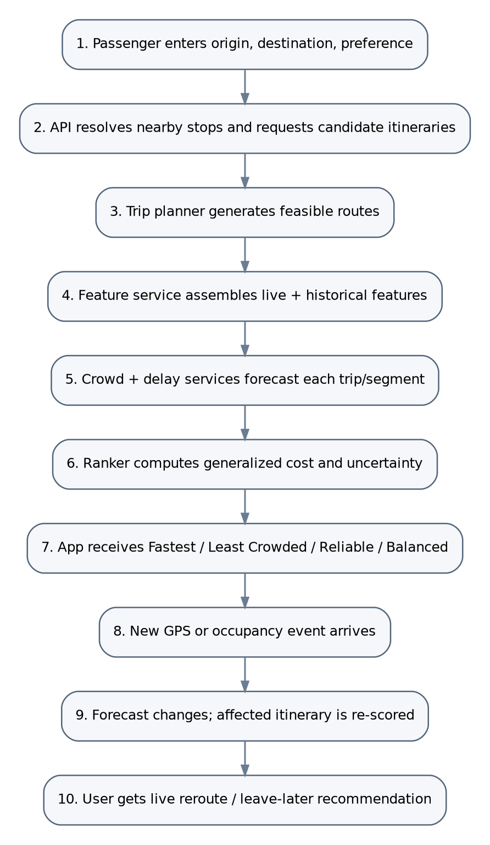
Figure 3. Passenger planning and live re-recommendation sequence

13.1 Initial journey plan flow
1. Resolve coordinates and nearby transit stops; filter inaccessible/invalid stops.
2. Generate candidate itineraries using the requested departure time and service calendar.
3. Batch the candidate trip/segment IDs into one feature request to avoid N+1 model calls.
4. Predict crowding and delay for each candidate at the relevant future stop/time.
5. Calculate expected journey metrics and confidence ranges.
6. Rank candidates, label alternatives, and return explanation strings derived from the scoring terms.
7. Cache the result using origin/destination grid cells, departure bucket, preference and feed/model versions.

13.2 Live update flow
A new GPS position or occupancy observation updates only the affected vehicle/trip/route features. If the forecast change exceeds a material threshold, the recommendation service checks active journey subscriptions touching those entities. Re-ranking is selective. The user is notified only if the preferred route changes or a meaningful warning threshold is crossed.

13.3 Operator hotspot flow
1. Every forecast cycle aggregates predicted occupancy and delay by route-stop-time bucket.
2. Capacity exceedance probability and duration are computed.
3. Adjacent stop buckets are merged into corridor hotspots.
4. Rules estimate interventions: added capacity, headway adjustment, short-turning or passenger information only.
5. Operator sees risk level, lead time, affected stops and supporting evidence.

14. Deployment architecture
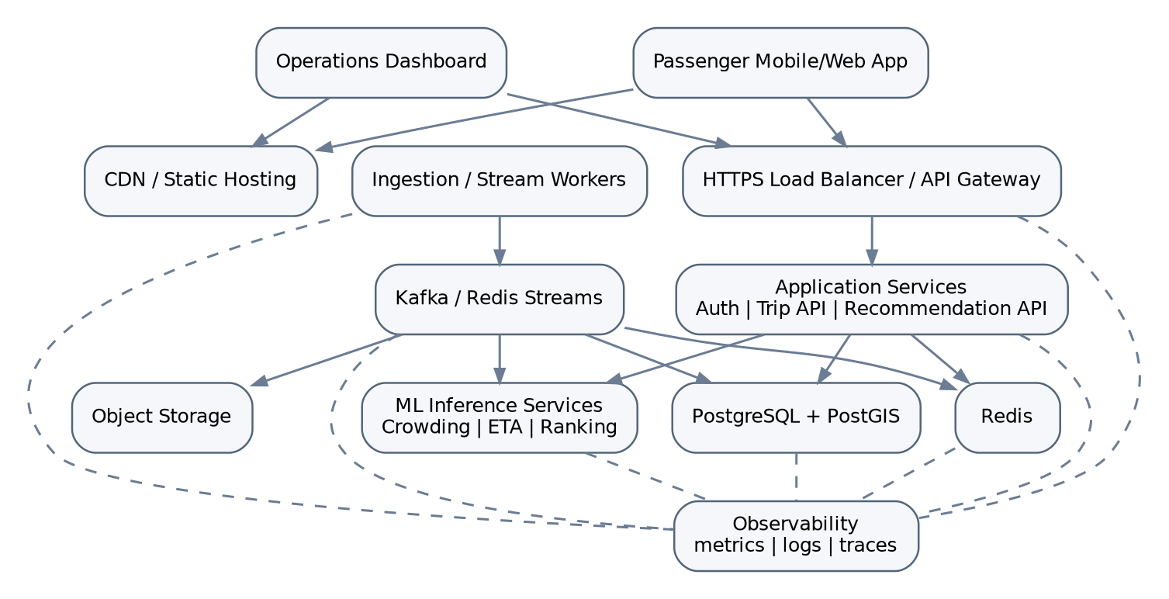
Figure 4. Production deployment topology

14.1 SIH demo profile
The logical services can be deployed in a compact profile without changing interfaces:
- Frontend: React/Next.js or Flutter web/mobile.
- Backend: one FastAPI application containing trip planning, recommendation and admin APIs.
- ML: crowd and delay models loaded in the FastAPI process or one separate inference service.
- PostgreSQL + PostGIS (optionally TimescaleDB) for GTFS, telemetry and forecasts.
- Redis for latest-state cache and live update pub/sub.
- Background workers for GTFS import, vehicle polling and synthetic/APC occupancy events.
- Docker Compose on a laptop or cloud VM; no Kubernetes required for the demo.

14.2 Production profile
- Containerized services behind a regional load balancer/API gateway.
- Kafka (or equivalent) partitioned by city/agency and route for telemetry fan-out.
- PostgreSQL/PostGIS high availability with read replicas for map/analytics traffic.
- Redis cluster for latest-state and route-plan cache.
- Object storage for raw and feature history.
- Independent autoscaling of ingestion, model inference, recommendation and dashboard workloads.
- Blue/green or canary model deployment with rollback.
- Cross-zone replication and managed backups.

14.3 Multi-city scaling
Introduce city_id and agency_id as first-class partition keys. Each city receives an adapter configuration describing timezone, GTFS feed, real-time source, capacity mapping and data-policy parameters. Core forecasting and ranking services remain shared or can be regionally isolated for data residency.

15. Security, privacy and governance
Area | Controls
Transport feed credentials | Secrets manager; never embed API keys in frontend; rotate and scope keys; outbound proxy if required.
Passenger authentication | Optional for anonymous planning; OAuth/OIDC for accounts; short-lived tokens.
Operator access | RBAC roles such as viewer, dispatcher, admin; MFA for privileged accounts.
Transport security | TLS everywhere; certificate validation; secure WebSocket.
Data at rest | Encrypted managed disks/object storage; backups encrypted.
Personal location | Process current origin/destination for routing; minimize historical retention; aggregate analytics to grid/stop level.
Crowd reports | Rate limit, abuse detection, coarse identity/reputation; do not expose reporter identity.
Audit | Record operator actions, model deployments, feed configuration changes and privileged data exports.
Input safety | Schema validation, maximum payload sizes, geospatial bounds, SQL parameterization, API rate limits.
Supply chain | Pinned dependencies, container scanning, SBOM in production pipeline.

15.1 Privacy-by-design
- Route planning can be anonymous. A user account is not required for the core value proposition.
- Active journey subscriptions use opaque session IDs and expire automatically.
- Do not persist raw device trajectories for analytics unless the user explicitly opts in and a legitimate retention purpose exists.
- Prefer aggregated OD demand counts with minimum group sizes over individual histories.
- If personalized preferences are stored, keep them separate from raw location history.
- Crowding model training should rely on vehicle/stop aggregates rather than personal passenger identities.

15.2 Threat examples
Threat | Impact | Mitigation
Fake crowd reports | Manipulated route recommendations | Consensus, rate limits, source weighting, anomaly detection, trusted APC precedence.
Stolen transit API key | Feed abuse or quota exhaustion | Server-side secrets, rotation, IP restrictions if supported.
GPS spoof/outlier | Bad ETA/crowd features | Map-match, impossible-speed checks, multi-point consistency.
Model poisoning through synthetic data | Biased production model | Provenance filtering; production training excludes simulated labels unless explicitly allowed.
Sensitive trip history exposure | Privacy harm | Minimal retention, access controls, aggregation, encryption.

16. Reliability, scalability and observability

16.1 Graceful degradation matrix
Failure | System behavior | User/operator indication
Live vehicle feed stale | Use last position + historical segment model; increase uncertainty | “Live tracking delayed” badge
Occupancy missing | Use historical/passenger-flow prediction without current load anchor | Crowd forecast marked lower confidence
Weather feed unavailable | Use last forecast or omit weather features with missing flag | No hard failure
ML service unavailable | Fallback to seasonal crowd and historical ETA baseline | Recommendation remains available; “estimated from history”
Redis unavailable | Read latest state from DB; disable some live subscription speedups | Higher latency, no data loss
One city feed broken | Isolate by city/agency partition | Other cities continue normally

16.2 Observability
- Metrics: ingest lag, feed freshness, positions/minute, map-match failure rate, missing occupancy coverage, model latency, API p50/p95/p99, cache hit rate.
- Model metrics: online error when labels arrive, calibration, feature drift, prediction distribution drift, fallback rate.
- Business metrics: journeys planned, live reroutes, least-crowded preference use, predicted hotspot lead time.
- Logs: structured JSON with request_id, city_id, route/trip/vehicle IDs, model_version; never log raw secrets.
- Traces: distributed trace from /plan through planner -> feature service -> model -> ranker to diagnose latency.
- Dashboards: source health, application SLO, model health and city operations views separated by audience.

16.3 Capacity model
Telemetry dominates write volume. If N vehicles report every R seconds, event rate is approximately N/R vehicle-position events per second before duplication and derived events. Partition the event bus and time-series tables by city/route, batch database inserts and keep only the latest state in Redis. Passenger route searches are read-heavy and highly cacheable by origin/destination grids and departure-time buckets.

17. MLOps and model lifecycle
1. Archive raw immutable events with source provenance.
2. Run data-quality checks and construct labels after enough future data exists.
3. Build an offline feature dataset using the same transformation definitions as online features.
4. Train baseline and candidate models with chronological splits.
5. Evaluate global metrics and critical slices: peak hours, rain, events, high occupancy, sparse routes.
6. Register candidate with dataset version, code commit, feature schema and metrics.
7. Deploy shadow/canary model; compare predictions without changing user output.
8. Promote only if quality, latency and calibration gates pass.
9. Monitor error/drift; retrain on schedule or when drift threshold is exceeded.
10. Rollback by model version without changing API clients.

17.1 Online/offline feature parity
One of the biggest ML-system risks is training-serving skew. Feature definitions such as “previous 3 stop occupancies”, “route-stop median for this 15-minute bucket” and “headway ratio” should be implemented once and reused by batch training and live inference, or validated with parity tests.

17.2 Model governance metadata
model_version
training_window
dataset_version
feature_schema_hash
target_definition
metrics_global
metrics_peak_hour
metrics_high_occupancy
calibration_metrics
approved_by
deployment_stage
created_at

18. Testing and validation strategy
Layer | Tests
GTFS importer | Schema validity, referential integrity, service calendar expansion, coordinate bounds, duplicate IDs, shape continuity.
Realtime ingestion | Protocol decoding, stale timestamps, duplicate events, impossible speeds, network retries, malformed feed.
Map matching | Known route trajectories, loops, crossings, out-of-order GPS, sparse points.
Occupancy | Capacity limits, board/alight conservation, conflicting crowd reports, stale sensors.
Feature pipeline | Offline/online parity, lag windows, missing values, timezone/daylight handling.
ML | Chronological holdout, peak/high-crowd slices, calibration, leakage checks, baseline comparison.
Routing | No-route case, transfers, overnight GTFS times >24:00, service exceptions, accessibility constraints.
Ranking | Preference weight tests, deterministic ordering, uncertainty penalties, hysteresis.
API | Contract tests, auth/RBAC, rate limit, payload validation, idempotency.
Performance | City-scale replay, burst passenger searches, cache behavior, p95 latency.
Resilience | Feed outage, Redis restart, model rollback, database failover, stale feature fallback.
Demo | Scripted scenario replay with fixed seed and offline fallback so presentation works without internet.

18.1 Synthetic simulation validation
The simulator should generate board/alight events from explicit behavioral rules rather than random occupancy percentages. Example rules: AM/PM peak multipliers, stop-specific boarding propensity, destination-driven alighting, rain/event multipliers, capacity clipping and route-specific demand profiles. The simulator output is tested for conservation, realistic peak patterns and repeatability by seed.

19. SIH demo architecture and script

19.1 Demo data composition
Layer | Demo choice
Transit network | Real Delhi GTFS routes/stops/trips.
Vehicle movement | Delhi real-time feed if API key/network available; otherwise replay a recorded real feed snapshot.
Weather | Real API response or cached recent/historical response.
Occupancy | Simulator or physical APC sensor; clearly flagged simulated in backend metadata.
Historical model data | Accumulated live feed + simulator occupancy; optionally validate passenger-flow method on external real dataset.
Maps | Real stop/route geometry; vehicle markers animated from live/replayed GPS.

19.2 Five-minute judge flow
Time | Screen | What happens
0:00–0:30 | Problem | “Today’s route planners optimize primarily for time. We predict how crowded and delayed a vehicle will be when it reaches you, then optimize the journey before the problem happens.”
0:30–1:20 | Plan journey | Enter origin/destination. Show three routes with ETA, predicted crowd and delay risk; choose Balanced.
1:20–2:10 | Prediction proof | Open the selected bus: current occupancy 52%, predicted 87% at the boarding stop. Show stop-by-stop forecast.
2:10–2:50 | Live event | Inject APC/simulator boarding spike or replay real crowd event. Forecast crosses threshold; selected route score worsens.
2:50–3:30 | Adaptive decision | System recommends Bus 22 or “leave 15 min later”, quantifying time vs crowd improvement.
3:30–4:20 | Operator view | Switch to dashboard: predicted corridor hotspot and delay/bunching window; suggested extra capacity/headway action.
4:20–5:00 | Architecture/credibility | Show data provenance: real GTFS + live/replayed GPS + weather; occupancy source flagged; explain production APC/AFC plug-in and uncertainty.

19.3 Demo “wow moment”
The strongest moment is not the initial route list. It is the live transition: a new vehicle/crowd event changes the predicted future occupancy, the route score changes, and the app explains why it is recommending a different bus or departure time.

19.4 Demo safety net
- Cache GTFS and map geometry locally.
- Record a short real vehicle-position sequence and support deterministic replay.
- Use a fixed simulator seed for occupancy so the demo is repeatable.
- Have a “live mode” and “replay mode” toggle that uses identical event contracts.
- Pre-warm ML models and route graph before judging begins.
- Never depend on an external API responding at the exact demo moment.

20. Implementation roadmap
Phase | Deliverable | Exit criteria
P0 – Data foundation | GTFS importer, PostGIS schema, map with stops/routes, feed provenance | Real network visible; feed versioning works.
P1 – Live fleet | VehiclePositions adapter/replay, vehicle markers, map matching, latest-state cache | Vehicles move on correct routes with freshness indicator.
P2 – Occupancy pipeline | Simulator + occupancy contract + optional sensor/crowd report | Current occupancy propagates through system and is source-tagged.
P3 – Forecasting baseline | Historical aggregates + GBDT crowd/ETA baseline + quantiles | Backtest beats seasonal baseline on chosen dataset/simulator.
P4 – Trip planning/ranking | Candidate itineraries + four preference profiles + explanations | Same OD returns clearly differentiated choices.
P5 – Live adaptation | Event-triggered re-score + WebSocket/SSE notifications | Injected crowd/delay event changes recommendation live.
P6 – Operator dashboard | Hotspot map, route forecast, fleet health | Future hotspot displayed with lead time and supporting metrics.
P7 – Hardening | Offline demo replay, tests, monitoring, pitch metrics | Full 5-minute flow repeatable without external dependencies.

20.1 Suggested team split
Workstream | Responsibilities
Data/backend | GTFS, realtime adapters, database, APIs, stream/replay engine
ML | Feature generation, crowd model, delay model, uncertainty, evaluation
Routing/optimization | Trip planner, preference scoring, departure-time optimization, reroute logic
Frontend | Passenger journey UX, map, charts, live update states
Dashboard/devops | Operator view, telemetry health, deployment, observability, demo automation

21. KPIs and acceptance criteria
Category | KPI | Prototype target / interpretation
Data | Vehicle-feed freshness | Show age; target majority of live vehicles within upstream feed cadence.
Data | Map-match success | >95% on clean replay sample; investigate route-loop edge cases.
ML | Crowd MAE / class F1 | Report honestly on real or simulated validation set, separated by source.
ML | ETA MAE | Compare against static schedule and historical median baseline.
ML | Calibration | p90 intervals should contain roughly the expected share of observed outcomes.
Product | Recommendation latency | p95 <2.5 s target for demo-sized deployment.
Product | Reroute reaction | Material injected event reflected in active journey within seconds.
Explainability | Reason coverage | Every ranked option has human-readable reason codes.
Operator | Hotspot lead time | Demonstrate forecast before capacity threshold occurs.
Reliability | Offline demo success | Full scripted flow works with replay mode and no internet.

22. Risks and mitigations
Risk | Why it matters | Mitigation
No public Delhi occupancy ground truth | Main crowd target is missing | Use canonical occupancy adapter; simulator for demo; APC/AFC/crowd integration path; external real passenger-flow benchmark.
Static timetable is approximate | Naive schedule-delay labels can be misleading | Use GTFS for topology/service; derive operational segment times from live vehicle history.
Realtime API unavailable during demo | Live feature can fail visibly | Recorded feed replay through same event contract.
Synthetic data perceived as fake | Judge credibility risk | Explicitly label; never claim real-world accuracy; keep network/GPS/weather real where possible.
Model over-complexity | Hard to debug and explain | Strong baseline first; advanced model only if measured improvement.
Sparse routes/new routes | Poor historical features | Hierarchical features by corridor/time; route-agnostic features; uncertainty/fallback.
Crowd reports manipulated | Wrong comfort prediction | Source weighting, consensus, rate limiting, anomaly detection.
Recommendation churn | Bad UX | Hysteresis, minimum benefit threshold, cooldown.
Privacy concerns | User trust/regulatory risk | Anonymous planning, short-lived sessions, aggregate analytics.
City-scale load | Telemetry and map queries grow quickly | Partitioning, batching, cache, spatial indexes, selective recomputation.

23. Future extensions
- Network graph neural networks that model congestion/crowding propagation across shared corridors and transfer hubs.
- Operator digital twin: simulate adding/removing vehicles and estimate passenger impact before dispatching.
- Fairness-aware routing so crowd redistribution does not consistently disadvantage specific neighborhoods or accessibility groups.
- Integration with metro, suburban rail, ferries and shared mobility in one multi-modal planner.
- Personalized comfort model learned from explicit preferences rather than sensitive personal attributes.
- Carbon-aware recommendations and mode-shift analytics.
- On-device or privacy-preserving crowd sensing from Bluetooth/Wi-Fi counts where legally appropriate.
- Incident/service-alert NLP that converts operator text alerts into route constraints.
- Reinforcement-learning research for fleet rebalancing, gated behind simulation and human approval.
- Open API for third-party mobility apps and campus/corporate shuttle operators.

24. Technology stack
Layer | Recommended | Alternatives / notes
Passenger UI | Flutter or React Native; web demo in React/Next.js | Use a single codebase if mobile is required.
Operator UI | React/Next.js + map component | Server-side auth/RBAC.
Backend APIs | Python FastAPI | Good fit with Python ML; async I/O for feeds.
Transit planning | RAPTOR/CSA implementation or GTFS routing engine | Keep behind TripPlanner interface.
Operational DB | PostgreSQL + PostGIS | Can add TimescaleDB for telemetry.
Cache/state | Redis | Latest vehicle state, plan cache, pub/sub.
Streaming | Kafka in production; Redis Streams for compact prototype | Same canonical events.
Object storage | S3-compatible storage + Parquet | Raw archives and ML datasets.
ML baseline | LightGBM/XGBoost/CatBoost + scikit-learn | Fast tabular/time-feature inference.
Advanced ML | PyTorch TFT/LSTM/Transformer/GNN | Only after baseline comparison.
Model registry | MLflow or equivalent | Metrics, artifacts, promotion/rollback.
Batch orchestration | Prefect/Airflow | Feature jobs, retraining, backfills.
Observability | Prometheus + Grafana + structured logs | OpenTelemetry tracing in production.
Packaging | Docker; Docker Compose demo; Kubernetes production | Do not introduce orchestration complexity into SIH demo unless needed.

25. References
Ref | Source | URL | Used for
[R1] | Delhi Open Transit Data – Static Data | https://otd.delhi.gov.in/data/static/ | Static Delhi bus GTFS download and published counts.
[R2] | Delhi Open Transit Data – Real Time Data | https://otd.delhi.gov.in/data/realtime/ | API access form; includes Student Projects use case.
[R3] | Delhi Open Transit Data – Documentation | https://otd.delhi.gov.in/documentation/ | GTFS files, VehiclePositions endpoint pattern, and timetable accuracy warning.
[R4] | GTFS Schedule Reference | https://gtfs.org/documentation/schedule/reference/ | Canonical GTFS file/field definitions.
[R5] | GTFS-Realtime – Vehicle Positions | https://gtfs.org/documentation/realtime/feed-entities/vehicle-positions/ | Vehicle position semantics and optional occupancy status.
[R6] | Transport for London – Our Open Data / BUSTO | https://tfl.gov.uk/info-for/open-data-users/our-open-data | Real bus boardings, alightings and loadings dataset description.
[R7] | Open-Meteo – Historical Weather API | https://open-meteo.com/en/docs/historical-weather-api | Hourly historical weather variables and data sources.

Web references were verified on 27 August 2026. External APIs, terms, feed coverage and update cadence should be rechecked immediately before deployment.

Appendix A. Example payloads

A.1 Canonical vehicle-position event
{
"event_type": "vehicle.position",
"schema_version": 1,
"city_id": "delhi",
"agency_id": "...",
"vehicle_id": "...",
"trip_id": "...",
"timestamp": "2026-08-27T17:21:14+05:30",
"position": {"lat": 28.61, "lon": 77.23},
"speed_mps": 7.8,
"matched_segment_id": "seg_...",
"source_type": "PUBLIC_FEED",
"source_name": "delhi_otd",
"quality_score": 0.96
}

A.2 Occupancy observation
{
"event_type": "occupancy.observation",
"vehicle_id": "...",
"trip_id": "...",
"timestamp": "2026-08-27T17:21:20+05:30",
"onboard": 37,
"capacity": 50,
"occupancy_ratio": 0.74,
"occupancy_class": "STANDING_ROOM_ONLY",
"source_type": "APC",
"confidence": 0.94
}

A.3 Forecast response
{
"trip_id": "...",
"target_stop_id": "...",
"target_time": "2026-08-27T17:34:00+05:30",
"crowd": {"p10": 0.68, "p50": 0.84, "p90": 0.95, "class": "VERY_CROWDED"},
"eta": {"p10": "17:31", "p50": "17:34", "p90": "17:39"},
"model_version": "crowd_gbdt_2026_08_27",
"feature_timestamp": "2026-08-27T17:21:20+05:30",
"data_freshness_sec": 8
}

A.4 Ranked itinerary response
{
"preference": "BALANCED",
"options": [
{"rank": 1, "label": "RECOMMENDED", "route": "Bus 22", "travel_min": 39,
"crowd_at_boarding": 0.42, "delay_risk": 0.18, "score": 0.31,
"reasons": ["Lower predicted crowding", "Low delay uncertainty"]},
{"rank": 2, "label": "FASTEST", "route": "Bus 31", "travel_min": 31,
"crowd_at_boarding": 0.72, "delay_risk": 0.41, "score": 0.46}
]
}

Appendix B. Judge-facing technical answers
Question | Answer
Where is your real data from? | The reference implementation uses official GTFS schedule/topology and an authorized GTFS-Realtime/AVL vehicle feed where available. Delhi OTD is the reference source. Weather can be real API data. Occupancy is an adapter: APC/AFC/operator data in production and a clearly labeled simulator or sensor prototype in the hackathon.
Isn’t synthetic occupancy fake? | It is a controlled substitute for a data source that normally belongs to the operator. The system tags it as simulated and does not present simulator metrics as real-world accuracy. The production contract accepts real APC/AFC/crowdsourced load data without changing the architecture.
What is actually AI here? | Spatiotemporal crowd/passenger-flow forecasting, ETA/delay forecasting and uncertainty estimation. Routing itself is deterministic; ML predicts future route conditions and the ranker optimizes decisions using those predictions.
How is this different from Google Maps? | The design centers on future occupancy and comfort/reliability-aware routing, plus operator-side predictive hotspots. The target is “how crowded will this vehicle be when it reaches me?” and “should I leave later or choose another route?”, not only shortest-time navigation.
Why not use only current occupancy? | Current load can be misleading. A half-empty bus may pass a major boarding hub before reaching the user; a currently crowded bus may empty before the user boards. Stop-level passenger-flow prediction is the real value.
How do you handle bad predictions? | Quantile uncertainty, source freshness, fallback baselines, confidence-aware ranking, monitoring and explicit degradation states. The app does not claim certainty.
Can this scale to a city? | Yes. Telemetry is partitionable by city/route/vehicle, live state is cached, historical data is append-only, and model/routing services scale independently. The demo can collapse the same logical services onto one node.
What would you need from a transport authority? | Vehicle/route master data, AVL feed, vehicle capacity, and ideally APC/AFC or occupancy data. The platform can start with GTFS + AVL and improve as richer feeds are connected.
What is the strongest demo proof? | Inject or replay a real-time event that changes future occupancy/delay, then show the recommendation and operator hotspot update live. This proves the system is predictive and adaptive rather than a static dashboard.

End of document.

